**MLSP Project Proposal**

**Team Members**

Ruxiao Duan, Tingying Lu, Weichen Qi, Yifan Zhou, Qihua Gong

**Project Title**

Cervical Spine Fracture Detection

**Background and Goal**

Human cervical spine consists of seven individual bones, which are given names C1, C2, up to C7 from top to bottom. This project aims to leverage machine learning techniques (mostly convolutional neural networks) to identify fractures on human cervical vertebrae, at both the level of a single vertebra and the entire patient. That means the model to be constructed should be able to not only detect the fracture for a patient overall, but also predict which vertebrae the fracture is located.

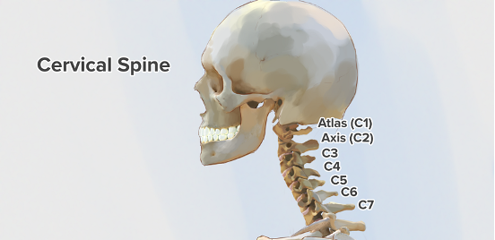

**Dataset and Task Description**

The medical images used in this project for model training and testing are retrieved from the public dataset created by Radiological Society of North America (RSNA), [American Society of Neuroradiology (ASNR)](https://www.asnr.org/) and [American Society of Spine Radiology (ASSR)](https://www.theassr.org/). The images are mostly X-ray images of CT scans, which are collected from 12 sites on 6 continents, including approximately 3,000 CT studies. Spine radiology specialists from ASNR and ASSR have given expert image-level annotations to indicate the presence, vertebral level and location of any cervical spine fractures.

Image data of 2,019 CT studies among the entire dataset are publicly available. Each study contains about 200 to 600 slices, which are CT scan images from the top to the bottom of a patient’s neck, covering all the seven cervical vertebrae. The vertebrae with fractures of each patient are identified by specialists and the dataset contains that information.

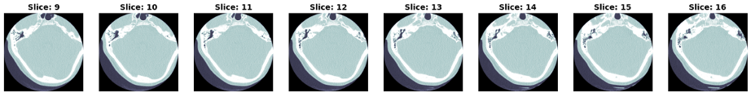

However, the vertebral index corresponding to each slice is not given for the images, i.e., we do not know which vertebra the slice is actually showing. Here comes the first challenge of the project: prediction of vertebral index for each slice of all the studies. Without such labels, it is impossible for the ultimate model to predict which vertebrae the fractures are located, even if the existence of a fracture is detected. Fortunately, 87 studies among the 2,019 have each slice annotated with vertebral index (to pixel-level), using which a model can be trained to predict the vertebral index for each slice. Furthermore, another model can be constructed to determine which part of the image is vertebrae and which part corresponds to the background. Masking can be achieved by such a model to increase the accuracy of fracture detection.

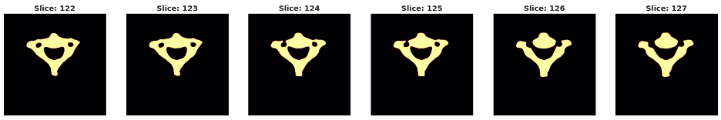

Beyond simply detecting the existence of a fracture and determining the vertebrae with fracture, a more powerful model can be trained to find the exact location of the fracture. Among all the studies, 239 of them have their fracture location given for each slice, if a fracture is present on that slice. Using this information, a bounding box can be drawn for the slice to capture where the fracture is on that image. This subset of data can hopefully help to build a model to locate the exact position of a fracture.

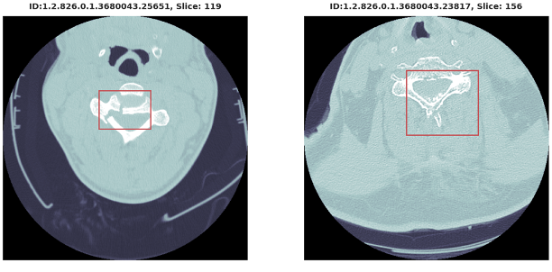

In the final stage, 3D visualization of the cervical spine will be realized by stacking all the slices vertically. The location of the detected fracture will be specifically highlighted in the 3D view of the vertebrae.

**Project Plan**

The project is divided into four main phases as specified as follows.

Stage 1: Data Exploration and Preprocessing

All the available data will be examined and processed for the sake of model training in later stages. Invalid samples will be identified and removed from the dataset, and only useful information will be retained for further usage.

Stage 2: Vertebrae Detection

Construct a model to predict which vertebrae a slice is showing, and generate vertebral index labels for all the slices in the dataset. Build another model to perform masking on the images to eliminate noises from the background, helping to increase the accuracy of fracture detection in the next stage.

Stage 3: Fracture Detection

Train a model to detect the presence of a fracture. After analyzing all the slices of a patient, the model should be able to give the individual probabilities of fracture on each vertebra from C1 to C7, and the overall probability of the patient having a fracture on any vertebra of the cervical spine.

Stage 4: Cervical Spine Visualization

Combine all the slices of a patient and construct a 3D visual model to show the shape of the patient’s cervical vertebrae. The position where a fracture is detected will be highlighted in the 3D model.